2003 Leaving Cert Physics Solutions (Ordinary Level)
1.
A student carried out an experiment to investigate the relationship between the force applied to a body and the acceleration of the body. The table shows the measurements recorded by the student.
Force /N | 0.1 | 0.2 | 0.3 | 0.4 | 0.5 | 0.6 | 0.7 | 0.8
Acceleration /cm s^{–2} | 8.4 | 17.6 | 25.4 | 35.0 | 43.9 | 51.5 | 60.4 | 70.0

- Draw a labelled diagram of the apparatus used in the experiment.
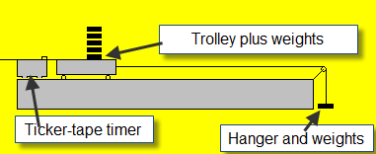

- How was the effect of friction reduced in the experiment?
Tilt the runway slightly, oil the track.
- Describe how the student measured the applied force.
By weighing the masses and hanger on an electronic balance.
- Plot a graph, on graph paper, of the acceleration against the applied force.
- What does your graph tell you about the relationship between the acceleration of the body and the force applied to it?
Acceleration is directly proportional to the applied force.

2.
In a report of an experiment to measure the specific latent heat of fusion of ice, a student wrote the following.
“Ice at 0 ⁰C was added to water in a calorimeter.
When the ice had melted measurements were taken.
The specific latent heat of fusion of ice was then calculated.”
- Draw a labelled diagram of the apparatus used.

- What measurements did the student take before adding the ice to the water?
Mass of calorimeter, mass of water, mass of calorimeter + water, mass of ice, temperature of water
- What did the student do with the ice before adding it to the water?
The ice was crushed and dried.
- How did the student find the mass of the ice?
(mass of calorimeter + water + ice) – (mass of calorimeter + water)
- Give one precaution that the student took to get an accurate result.
Insulation, crush, dry, repeat and take average, use lots of ice, transfer ice quickly.
3.
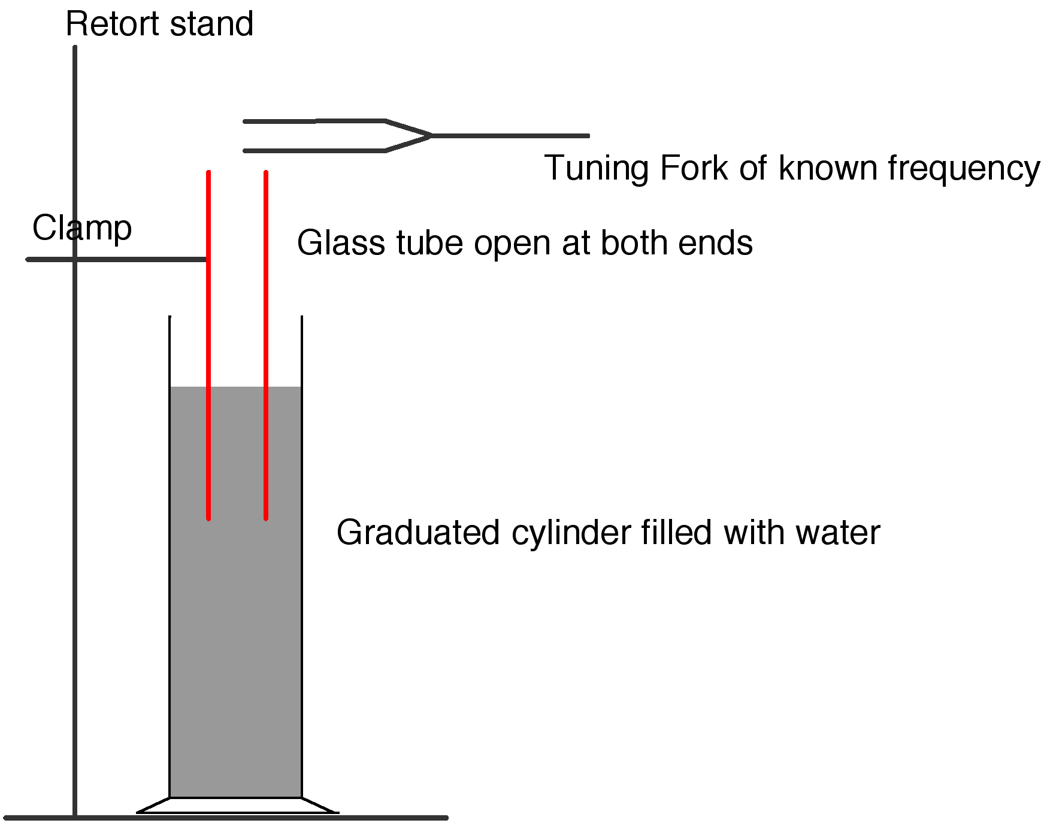
In an experiment to measure the speed of sound in air, a student found the frequency and the wavelength of a sound wave.
- Draw a labelled diagram of the apparatus used in the experiment.
See diagram.
- Describe how the student found the wavelength of the sound wave.
We measured the diameter of the inner tube using digital callipers.
We measured the length of the inner tube above the water.
We then used the formula λ = 4(l + 0.3d) to calculate the wavelength.
- How did the student find the frequency of the sound wave?
We read it from the tuning fork which was used to create the sound wave.
- How did the student calculate the speed of sound in air?
We substituted the values for frequency and wavelength into the formula c = f λ
- Give one precaution that the student took to get an accurate result.
Repeat using different tuning forks and take an average, clamp tube to take measurements.

4.
The diagram shows the circuit used by a student to investigate the variation of current with potential difference for a filament bulb.
- Name the apparatus X. What does it measure?
X is an ammeter. It measures current.
- Name the apparatus Y. What does it do?
Y is a voltmeter. It measures volts.
The table shows the values obtained for the current and the potential difference during the experiment.
Potential difference /V | 2.0 | 3.0 | 4.0 | 5.0 | 6.0 | 7.0 | 8.0 | 9.0
Current /A | 1.0 | 1.5 | 1.9 | 2.3 | 2.6 | 2.9 | 3.2 | 3.5

- Draw a graph, on graph paper, of the current against the potential difference.
- Use your graph to find the resistance of the bulb when the current is 3 A.
When the current is 3 A the voltage is 7.2 V, so using V = IR results in R = 2.4 Ω.
- The resistance of the bulb is 2.0 Ω when the current is 1.5 A
Explain why the resistance of the bulb when the current is 1.5 A is different from its resistance when the current is 3 A.
Because the resistance of the bulb increases with temperature, and temperature is greater when the current is greater.

5.
- What is the momentum of an object with a mass of 5 kg travelling at 10 m s⁻¹?
Momentum = mass × velocity = 5 × 10 = 50 kg m s⁻¹.
- State Boyle’s law.
For a fixed mass of gas, pressure is inversely proportional to volume, assuming temperature is constant.
- Name a renewable source of energy.
Solar, wind, tidal, hydro, biomass
- The temperature of a body is 300 K. What is its temperature in degrees Celsius?
300 – 273 = 27 ⁰C.
- Name two methods by which heat can be transferred.
Conduction, convection and radiation.
- Give one difference between light waves and sound waves.
Light waves are transverse; sound waves are longitudinal
Light waves can be polarised; sound waves cannot be polarised
Light waves travel through vacuum; sound waves cannot travel through
- Describe the image that is formed in a concave mirror when an object is placed inside the focus, as shown in the diagram.
The image is virtual, magnified and upright.
- State one energy conversion that takes place in an electrical generator.
Kinetic to electric
- What is a transformer used for?
To increase or decrease voltage.
- Give two properties of the electron.
Small mass, negative charge, orbits the nucleus.

6.
- Copy and complete the following statement of Newton’s law of universal gravitation.
“Any two point masses attract each other with a force which is proportional to the product of their masses and inversely proportional to the square of the distance between them.”
- What is meant by the term acceleration due to gravity?
It is the acceleration which objects in freefall experience due to the pull of the earth.
- An astronaut of mass 120 kg is on the surface of the moon, where the acceleration due to gravity is 1.6 m s^{–2}. What is the weight of the astronaut on the surface of the moon?
W = mg = 120 × 1.6 = 192 N.
- The astronaut throws a stone straight up from the surface of the moon with an initial speed of 25 m s^{–1}. Describe how the speed of the stone changes as it reaches its highest point.
It slows?
- Calculate the highest point reached by the stone.
v² = u² + 2as ⇒ 0 = (25)² + 2 (-1.6) s ⇒ s = 195.3 m.
- Calculate how high the astronaut can throw the same stone with the same initial speed of 25 m s^{–1} when on the surface of the earth, where the acceleration due to gravity is 9.8 m s^{–2}.
v² = u² + 2as ⇒ 0 = (25)² + 2 (-9.8) s ⇒ s = 31.9 m.
- Why is the acceleration due to gravity on the moon less than the acceleration due to gravity on the earth?
The earth has a greater mass than the moon.

7.
- State the laws of refraction of light.
- The incident ray, the normal and the refracted ray all lie on the same plane.
- The ratio of the sin of the sin of the angle of incidence to the sin of the angle of refraction is a constant.
- Explain, with the aid of a labelled diagram (i) total internal reflection, (ii) critical angle
- Total internal reflection occurs when the angle of incidence in the denser of the two media is greater than the critical angle and light is reflected back into the denser medium.
- The critical angle corresponds to the angle of incidence in the denser of two media which causes the angle of refraction to be 90⁰.
- The diagram shows a 45º prism made of glass. The critical angle for the glass is 42º.
Calculate the refractive index of the glass.
n = 1/sin C ⇒ n = 1/ sin 42 ⇒ n = 1.5
- The diagram shows a ray of light entering the prism from air.
Copy the diagram and show the path of the ray through the prism and back into the air.
See diagram
- Explain why the ray follows the path that you have shown.
Because total internal reflection occurs twice while inside the prism.
- Give two uses of total internal reflection.
Fibre optics, endoscopes, reflective road signs.

8.
- What is an electric current?
An electric current is a flow of charge.
- Give the standard colour of the insulation on the wires connected to each of the terminals L, N and E on the plug in the diagram.
L (live) is brown, N (neutral) is blue, E (earth) is green-yellow
- What is the purpose of the wire connected to the terminal E on the plug?
The earth wire protects from electrocution / shock by conducting the current to earth.
- Explain why a fuse is used in a plug.
It ‘blows’ and breaks the circuit if too large a current flows, preventing possible electrocution.
- The fuse in the plug of an electric kettle was replaced with a 5 A fuse. The kettle has a power rating of 2 kW when connected to the ESB mains voltage of 230 V.
Calculate the current that flows when the kettle is first plugged in.
P = VI ⇒ I = P/V ⇒ I = 2000/230 = 8.7 A
- This current will only flow for a very short time. Explain why.
The current is larger than the fuse rating, so the fuse will blow.
- Bonding is a safety precaution used in domestic electric circuits. How does bonding improve safety in the home?
Bonding is where all metal pipes are connected to earth preventing accidental electrocution.
- Name a device that is often used nowadays in domestic electric circuits instead of fuses.
Miniature circuit breakers (MCBs) or residual current devices (RCDs).

9.
- What is a magnetic field?
A Magnetic Field is any region of space where magnetic forces can be felt.
- The earth has a magnetic field. Give one use of the earth’s magnetic field.
Navigation, protection from the solar winds.
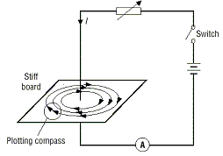
- Hans Oersted discovered the magnetic effect of an electric current in 1820 while demonstrating electricity to his students. Describe how you would demonstrate the magnetic effect of an electric current.
Apparatus: see diagram
Procedure: close the switch
Observation: compass deflects

- Draw a sketch of the magnetic field around a straight wire carrying a current. Your diagram should show the direction of the current and the direction of the magnetic field.

- In an experiment, a thin light conductor is placed between the poles of a U-shaped magnet as shown in the diagram. Describe what happens when a current flows through the conductor.
The conductor experiences a force and deflects.
- Name two devices that are based on the effect demonstrated in this experiment.
A loudspeaker, motor, galvanometer.
- What would happen if (i) a larger current flowed in the conductor, (ii) the current flowed in the opposite direction through the conductor?
- A bigger deflection
- The conductor would deflect in the opposite direction.

10.
- What is radioactivity?
Radioactivity is the breakup of unstable nuclei with the emission of one or more types of radiation.
- The diagram shows the basic structure of a nuclear reactor.
A nuclear reactor contains (i) fuel rods, (ii) control rods, (iii) moderator, (iv) heat exchanger.
Give the function of any two of these.
Fuel rod: source of energy
Control rod: controls the speed of the reaction by absorbing neutrons
Moderator: slows down neutrons
Heat exchanger: transfers heat energy
- In a nuclear reactor, energy is released by nuclear fission when a chain reaction occurs.
What is nuclear fission?
Nuclear Fission is the break-up of a large nucleus into two smaller nuclei with the release of energy (and neutrons).
- What is a chain reaction?
This occurs when at least one neutron gets released during fission causing more fission to occur in another nucleus and this then becomes a self-sustaining reaction.
- Thick shielding is placed around a nuclear reactor because of the penetrating power of the radiation emitted. Name three types of radiation that are present in a nuclear reactor.
Alpha, beta and gamma.
- Name an instrument used to detect radiation.
GM tube, solid state detector, cloud chamber, ionisation tube,
- Plutonium is produced in a nuclear reactor. It is a highly radioactive substance with a very long half-life. When the fuel in a nuclear reactor is used up, the fuel rods are reprocessed to remove the plutonium.
Give two precautions that are taken when storing the plutonium.
Use thick shielding, use a tongs.

11.
Read the following passage and answer the accompanying questions.
The operation of semiconductor devices depends on the effects that occur when p-type and n-type semiconductor material are in close contact. This is achieved by taking a single crystal of silicon and doping separate but adjacent layers of it with suitable impurities. The junction between the p-type and the n-type layers is referred to as the p–n junction and this is the key to some very important aspects of semiconductor theory.
Devices such as diodes, transistors, silicon-controlled rectifiers, etc., all contain one or more p–n junctions.
(“Physics – a teacher’s handbook”, Dept. of Education and Science.)
- What is a semiconductor?
A semiconductor is a material whose resistivity is between that of a conductor and insulator.
- Name a material used in the manufacture of semiconductors.
Silicon, germanium
- Name the two types of charge carriers in semiconductors.
positive holes and electrons.
- What is meant by doping?
Doping is the addition of suitable impurities to improve conductivity.
- Give one difference between a p-type semiconductor and an n-type semiconductor.
P-type material contains more holes than n-type material.
N-type material contains more free electrons than p-type material.
- What is a p-n junction?
It is the junction between the p-type and the n-type material.
- What is a diode?
A diode is a device that allows current to flow in one direction only.
- Give an example of a device that contains a rectifier.
Radio, television, computer, battery charger, mobile phone charger.

12.
(a)
- Define the moment of a force.
The moment of a force = the force × perpendicular distance between the force and the fulcrum.
- Explain why the handle on a door is on the opposite side to the hinges of the door.
In order to maximise the distance between the force and the fulcrum.
- A metre stick is suspended by a thread at the 20 cm mark as shown in the diagram. The weight W of the metre stick acts through the 50 cm mark. A weight of 2 N is placed at the 15 cm mark.
Calculate the moment of the 2 N weight about the 20 cm mark.
M = F × d = 2 × 0.05 = 0.1 N m.
- What is the moment of W about the 20 cm mark?
M = F × d = 0.3 W N m
- If the metre stick is in equilibrium, find the value of W.
0.1 = 0.3W ⇒ W = 0.33 N

(b)
- Name two primary colours.
Red, green, blue
- What are complementary colours?
Complementary colours are pairs of colours consisting of a primary and a secondary colour, such that when combined they give white light.
- White light is made up of light of different colours. Describe an experiment to demonstrate this.
Apparatus: white light source, prism, screen
Procedure: shine light through the prism and rotate the prism.
Observation: different colours are visible on the screen.
- The diagram shows a simple form of the electromagnetic spectrum, with wavelength increasing from left to right.
Copy this diagram and indicate on it the positions of the following:
microwaves; infrared; ultraviolet; X-rays.

(c)
- What is the unit of electric charge?
The Coulomb
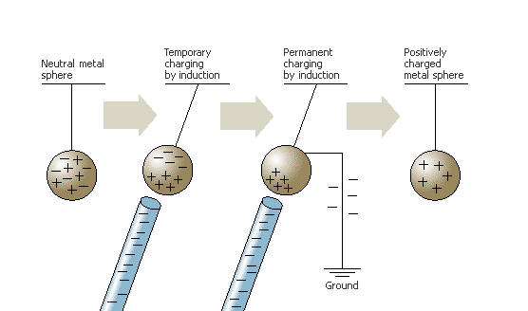
- Describe, with the aid of a labelled diagram, how you would charge a conductor by induction.
Apparatus e.g. conductor (mounted on insulated stand) and a charged rod
Bring a charged rod close to the conductor.
Earth the conductor by touching it with your finger while still holding the rod close by.
Remove your finger,then remove the rod.
- The build-up of electric charge can lead to explosions. Give two examples where this could happen.
Dust e.g. flour mill explosions, inflammable vapours e.g. fuelling aircraft, lightning
- How can the build-up of electric charge on an object be reduced?
Earthing the object

(d)
- What is a photon?
A photon is a packet of electromagnetic radiation.
- The diagram shows a photocell connected in series with a sensitive galvanometer and a battery.
Name the parts labelled A and B.
A is the cathode
B is the anode
- What happens at A when light falls on it?
Electrons are released
- What happens in the circuit when the light falling on A gets brighter?
The current increases.
- Give an application of a photocell.
Alarms, automatic doors, safety switches, light meters, solar cells etc.

